**Results for Website**

The website is the main interface that the user will have to interact with in order to fully utilise this system, so it was necessary to thoroughly test the website to ensure that it was functional, easy to use and secure.

The facets of the system that will be tested are going to cover multiple aspects of the system mainly the functionality of the website and mobile testing. More info on each aspect, as well as their results, will be given below. The overall website will also be evaluated for its browser compatibility as well as its speed, and usability.

**Login and Register**

A main part of any website nowadays, the developers had to ensure that users could easily login and register on the webpage.

The tests for this aspect of the system where performed by anonymous users as well as by the developers of the website, and the feedback produced was used to make modifications where appropriate.

**Functionality Testing**

This is the testing aspect that will affect users the most as it is a gage of whether or not users can perform the actions they need to by using the platform created.

After trying out the website the testers indicated that while the website works as it should there is no need for storing the name and surname of the person registering. Upon receiving this feedback, the developers removed those input fields from the form used for registering. This also meant that the application would be handling a smaller amount of sensitive data and therefore worries about security breaches are lessened to a certain extent.

**Mobile Testing**

With around 50% of the world’s internet traffic being served to mobile devices it was vital to ensure that users could easily use the web application from mobile devices.

Once the login and register functions where tested on mobile it was deemed that they implemented in such a way that was suitable for mobile devices as well. As shown in the Figures below.

A picture containing electronics

Description generated with very high confidenceA picture containing electronics

Description generated with high confidence

**Front Page Navigation**

The page that greets the user every time they access the web page had to be functional as well as attractive to use.

The tests for this aspect of the system where performed by anonymous users as well as by the developers of the website, and the feedback produced was used to make modifications where appropriate.

**Functionality Testing**

After allowing the testers to use the website’s landing page and try to casually browse the information presented in order to get a feel for the application, some feedback was generated. Testers stated that they found the site easy to use and browse. Testers also noted that they really enjoyed the smoothness with which the front page allows the users to navigate between the different slides.

**Mobile Testing**

To determine whether or not users could easily navigate the web app on mobile devices they were asked to try and perform the same action they had done on the desktop version of the website on a mobile device. Once they had done so the developers received feedback, it was determined that the testers found the front page a delight to navigate as it felt like an app more than a website. This was encouraging to the developers as that was the goal they set out when creating the web app. Example images of what the website looks like on mobile are shown below.

A picture containing fruit

Description generated with high confidence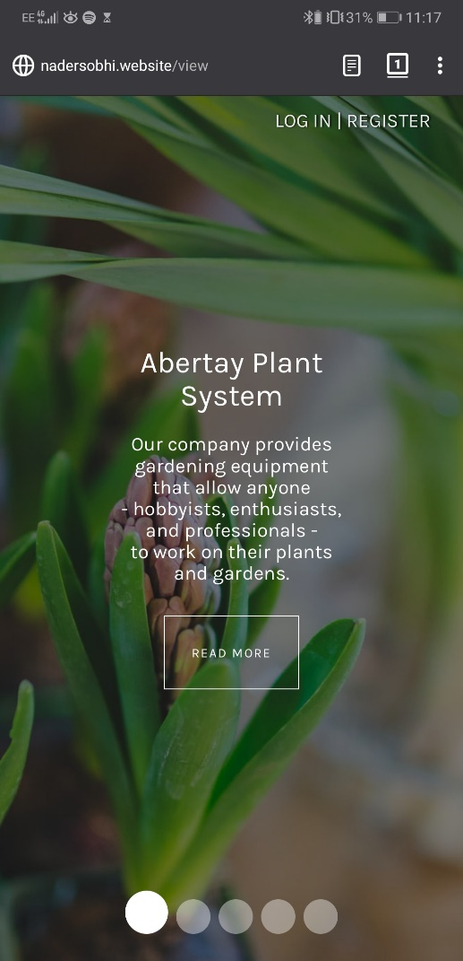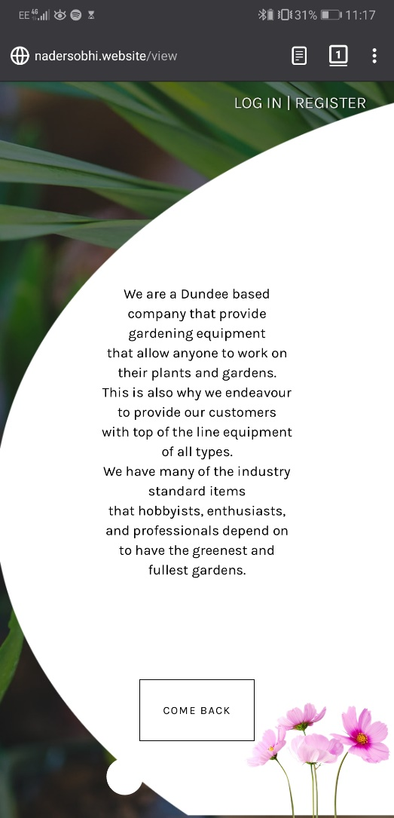

**Plants Panel Navigation**

Once the user has logged in they will be redirected to a panel that will allow them to view the readings that their device(s) has collected. They will also be able to add more devices should they need to.

The tests for this aspect of the system where performed by anonymous users as well as by the developers of the website, and the feedback produced was used to make modifications where appropriate.

**Functionality Testing**

The main feature that would need to be tested was the navigation between the different sections and graphs, as well as the functionality of the various available features. The features that would need to be tested are: Adding devices and plants to the users account, Switching the graphs view from a Day view to a Month or Week view, and using the back to top button. Once the testers tried the aforementioned features and casually browsed the page to get a feel for the ease of navigation of the webpage, they gave their feedback to the developers. The overall feedback was that the website was easy to browse, and the features were intuitive to use.

**Mobile Testing**

A screenshot of a cell phone

Description generated with very high confidenceA screenshot of a cell phone

Description generated with very high confidenceMaking this panel functional and usable on mobile was vital as it would allow users to check the status of their plants using their mobile device. Which makes the system created a utility since users can monitor their plant on the go. The feedback received was that while the website is functional and enjoyable to use on mobile devices, the font size on the graphs is rather small. This was noted down but not changed due to the fact that changing this might negatively affect the desktop version of the website. Examples of what the Plant Panel page looks like on mobile are shown below.

A screenshot of a cell phone

Description generated with very high confidenceA screenshot of a cell phone

Description generated with very high confidence

A screenshot of a cell phone

Description generated with very high confidence

**Overall website tests**

The website was then tested for its overall browser compatibility, speed, and usability. The reason these attributes were separated from the features tested above was that these attributes contribute to the overall feel of the website and not specific to any page or feature.

**Browser Compatibility**

In order to test the website on multiple browsers in a timely and efficient manner the developers used an online service provided on [browsershots.org](http://www.browsershots.org). This service allows the developer to view screenshots of any website they choose on 95 different browsers. These screenshots are shown in the next page. As seen is the screenshot all modern browsers and a lot of the older versions of popular browsers seem to function well also.

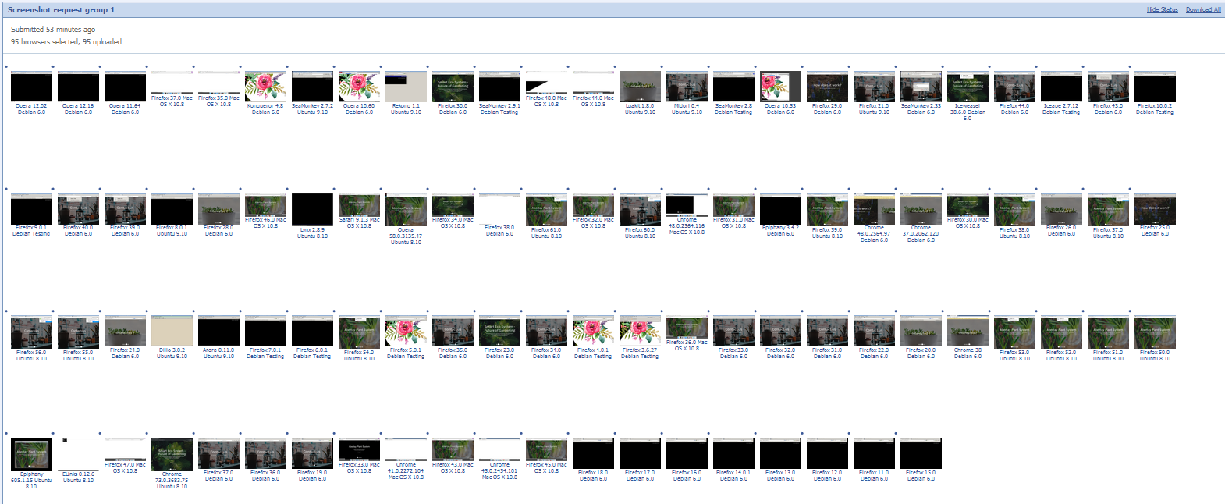

**Speed**

Another measure of responsiveness is the speed with which the website loads and responds to the users clicks and touches. There are a number of facilities online that allow a developer to view their websites performance, for the purposes of this website Google PageSpeed Insights and KeyCDN Speed Test were used. The results of these test are shown below.

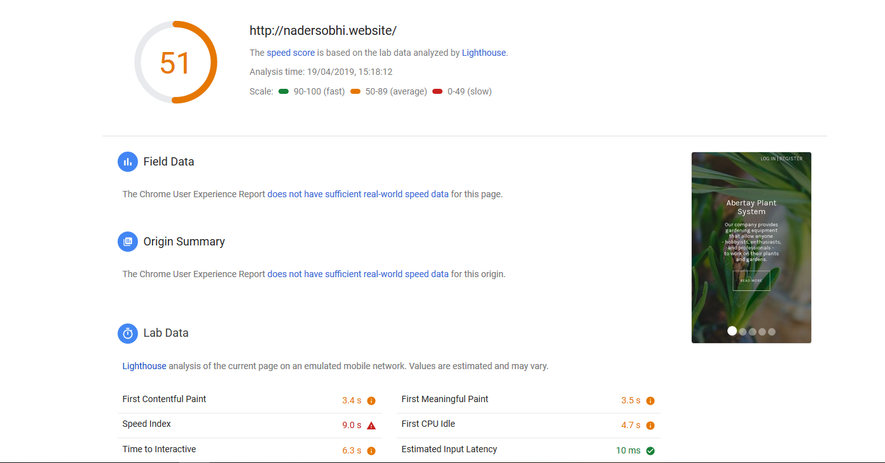

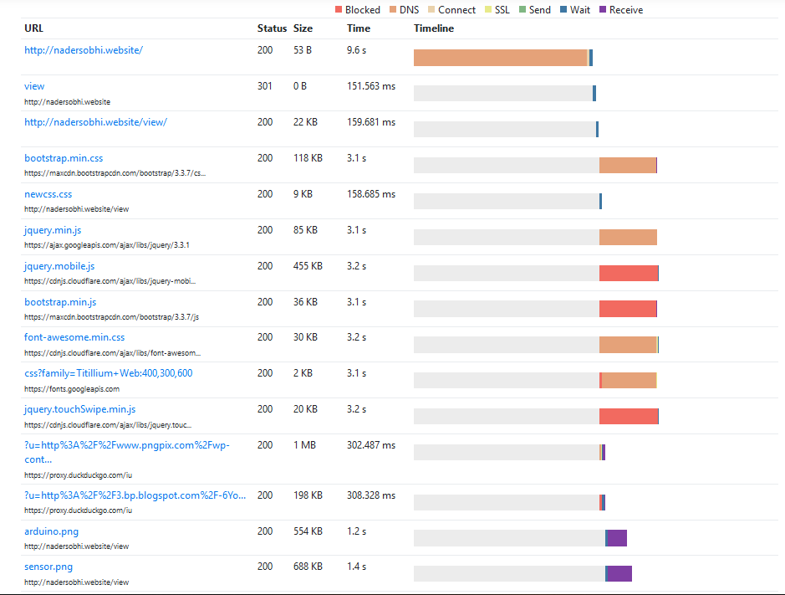

Upon analysis of the results it is clear that the website is not performing optimally in terms of speed. This is mainly due to the images used on the website which use old, outdated formats, this is shown below.

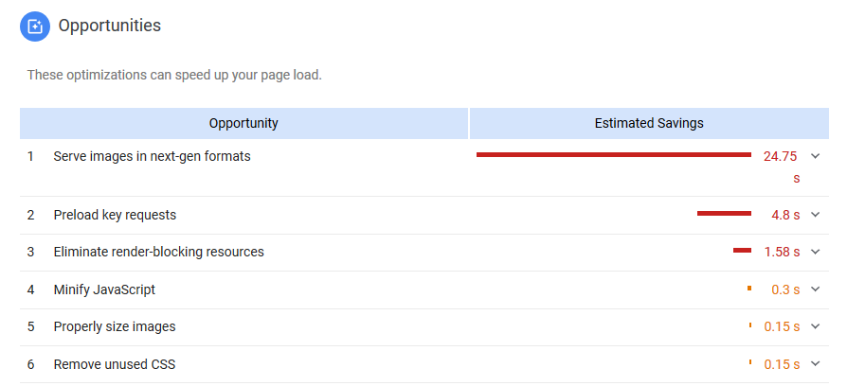

Unfortunately, these images are vital to the visuals of the website and therefore cannot be changed, a potential future change would be to convert these images to newer more efficient formats.